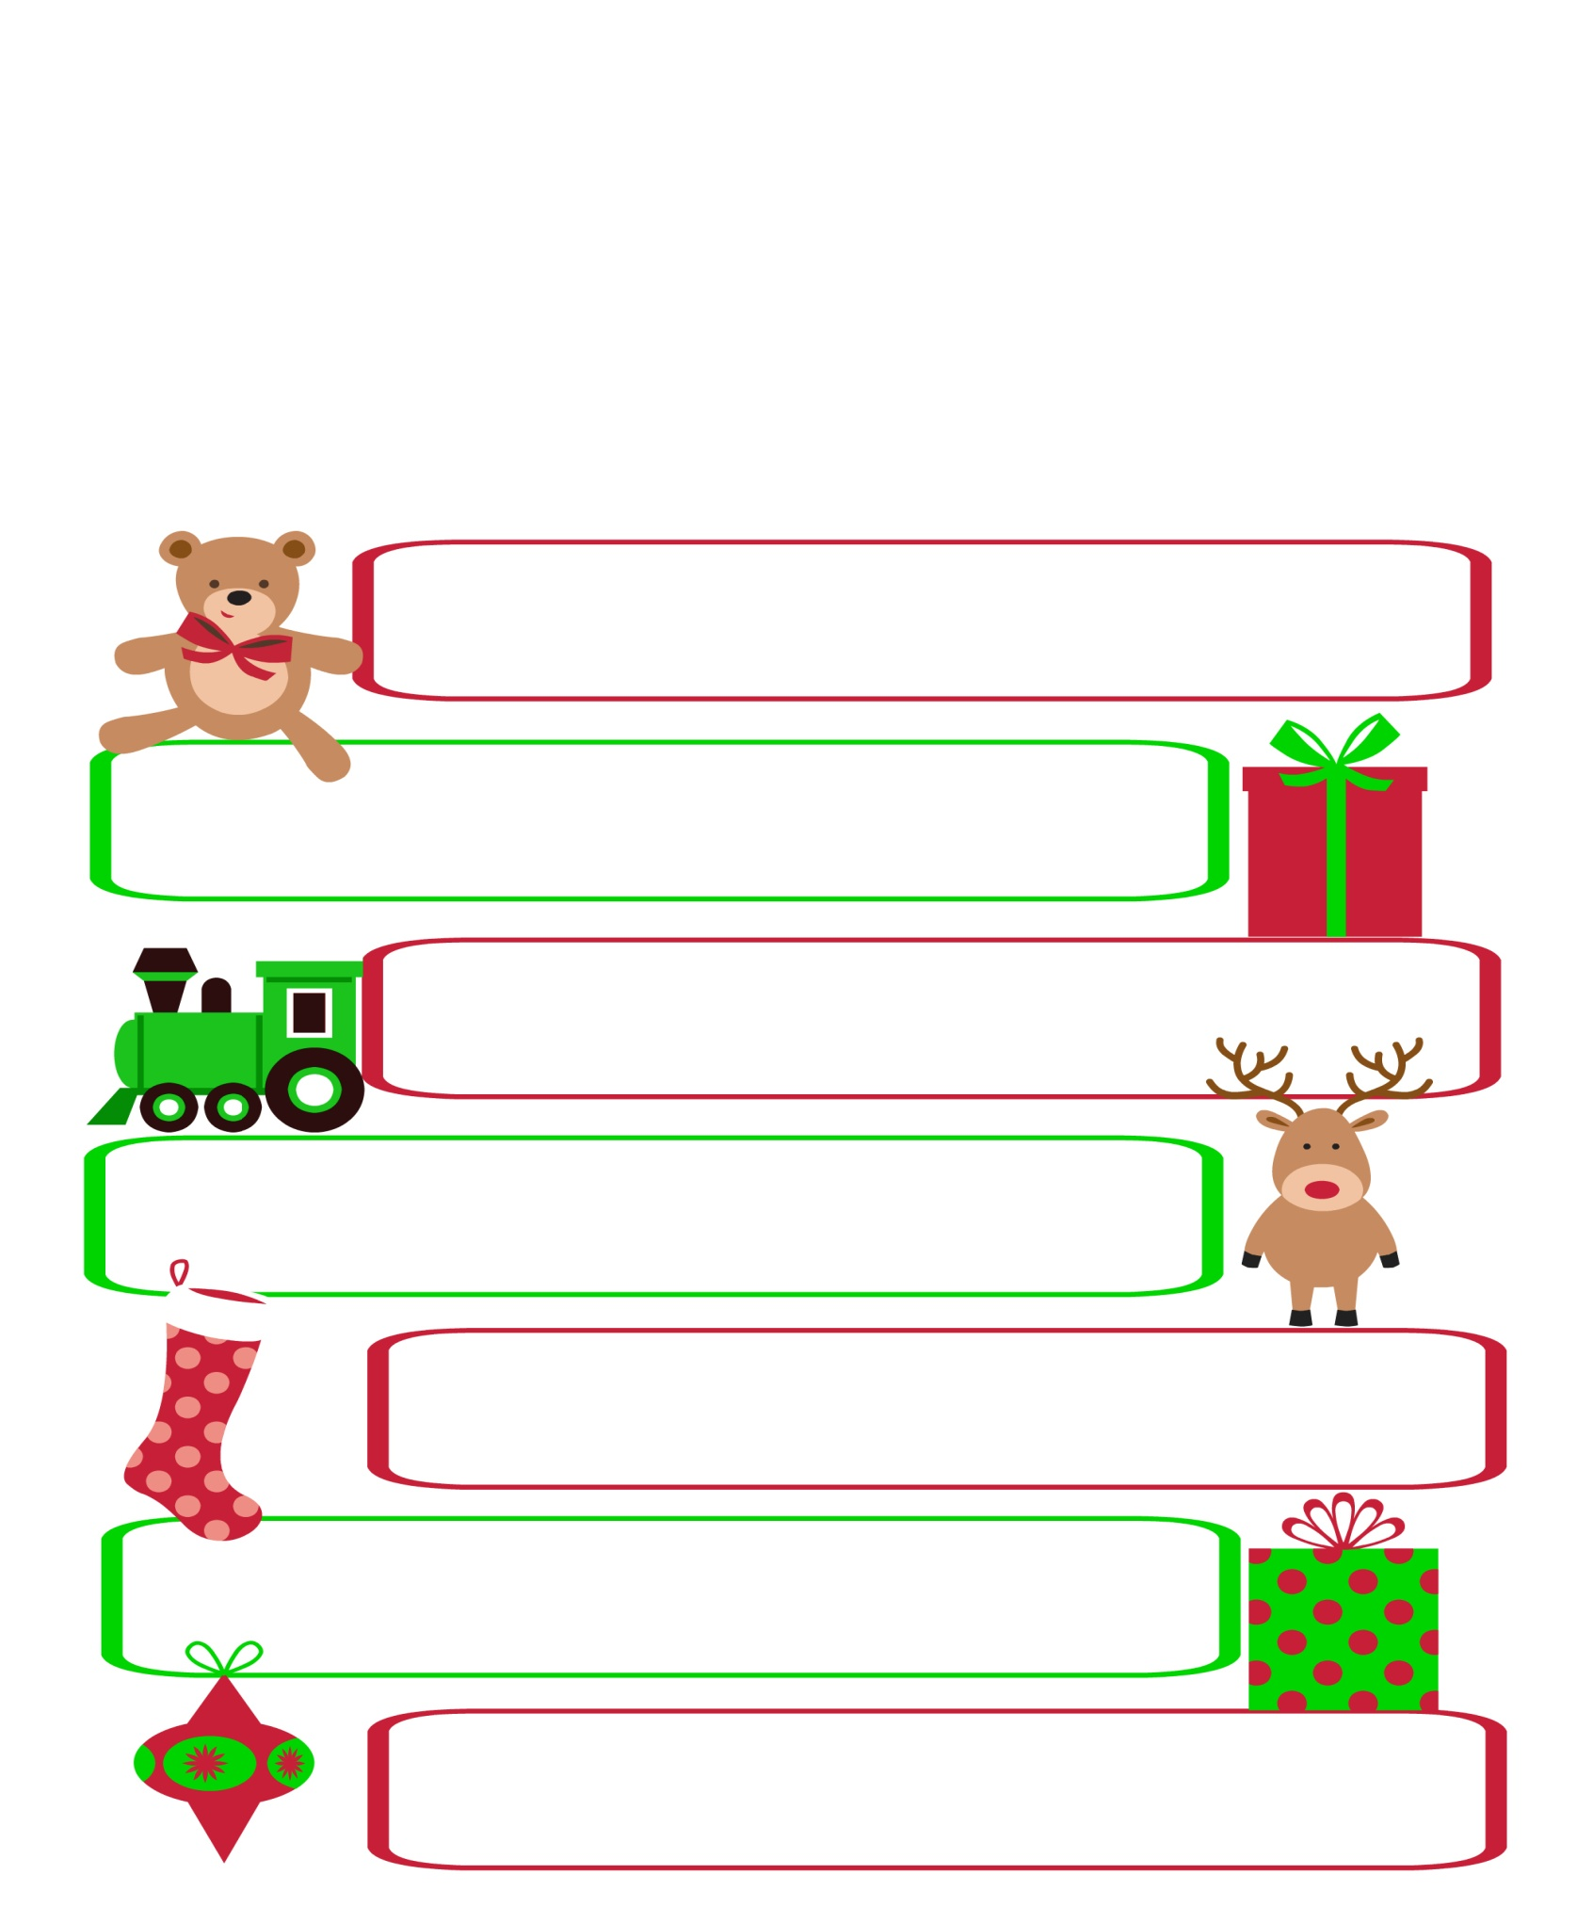
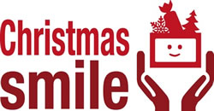
This Christmas not everyone in our community has a roof over their heads, a loving family, food on the table or gifts under the tree…
We at the Christmas Smile Project believe that every child should receive a gift at Christmas. With your help we aim to provide gifts to put a smile on the face of each child living under very difficult circumstances within the local area. This year we will also be including elderly residents who may be in difficulty or alone and without a gift this Christmas.
If you are able to provide a gift, please take it, unwrapped to your collection point by 5th December. A team will then collect, process, wrap and distribute the gifts in time for Santa’s arrival.
For full details, please visit our website: www.christmassmile.org.uk

GIFT SUGGESTIONS
Children 0-2
Cuddly Toys, baby clothes, puzzles, soft balls, rattles
Children 3-6 Colouring books and pencils, books, hats, gloves, scarves, early board games, toy cars, dolls, arts & crafts, kites…
Children 7-10
Footballs, frisbees, kites, hats, gloves, scarves, pencil cases,
jewellery, craft kits, books, puzzles…
Teens 11-16
Sports equipment, hats, gloves, scarves, toiletry sets, jewellery
makeup, nail varnish, purses, wallets, bags, PJs, Onesies…
Adults & Senior Citizens
Bath/shower sets, aftershave, books, gloves, scarf, nightwear,
puzzle books, handwarmers, bedsocks, water bottle, nail varnish…
Food Gifts
Selection boxes, chocolate coins Christmas puddings, biscuits,
Christmas cake, jam, sweets, mince pies…
Cash Donations
Please visit the website for details of how to donate

